Capital City

Beekeepers

Association

Name ___________________________

Address ___________________________

___________________________

City ___________________________

State ________________ Zip ________

Email ___________________________

Phone _______________ Date ________

Bee Data (Optional)

Current # of colonies: ______________________

Number of years beekeeping: ________________

What do you want from the Association?

(Rank order 1 [highest] to 8 [least important])

_____ Networking with other beekeepers

_____ Organized honey tastings and honey sales

_____ Practical 1-on-1 help getting started

_____ Community promotion of beekeeping

_____ Advanced beekeeping training

_____ Beekeeping mentoring

_____ 5% discount at Dadant on bee supplies

_____ Other: _____________________________

___________________________________

*Please submit dues {$10 individual or $15 family} payment to:*

Marsha Bezold

100 Lantern Trail

Midway, KY 40347

*Recent Activities…*

Monthly newsletter and technical classes

Volunteering at the KY State Beekeepers Association’s State Fair Honey Booths

Honey Booth at the Franklin County Farmers Market, Capital Area Extension Master Gardeners’ annual plant sale and Frankfort Candlelight Tradition

Sponsoring Honey Competition at the Franklin County Fair & Horse Show

Promoting of bees and beekeeping at numerous events in the surrounding area

Co-hosting of the annual Bluegrass Beekeeping School

School Presentations and Hive Painting Competition

School Presentations and Hive Painting Competition

*Member Benefits…*

* Networking with other beekeepers
* Practical 1-on-1 help getting started with beekeeping
* Small-group beekeeping mentoring
* Advanced beekeeping training
* Organized honey tastings and honey sales
* 5% discount at Dadant & Sons on bee supplies
* Discounts on Nucs and packages
* Consignment honey sales at Wilson Nurseries

**Capital City Beekeepers**

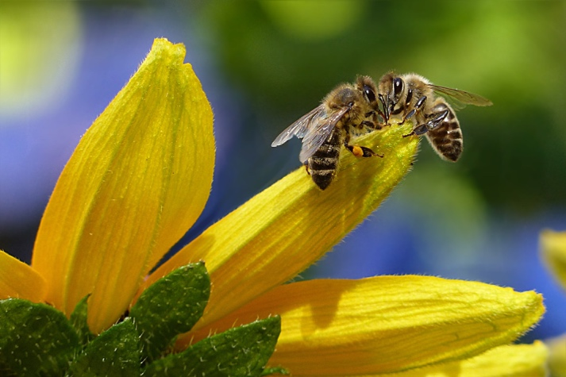

Providing Support,

Encouragement and a

Little Clear Thinking for

All Beekeepers in

Central Kentucky

CapitalBees.weebly.com

_______________________________

Valid January 2022

 BECAUSE ALL

BEEKEEPERS SHOULD THRIVE

“I like pulling on a baggy bees

suit, forgetting myself and

getting as close to the bees’

lives as they will let me,

remembering in the process

that there is more to life

than the merely human

life.” *Sue Hubbell*

OFFICERS

_____________

**President – Wes Henry**

[**wesnky@yahoo.com**](mailto:wesnky@yahoo.com)

**Vice President – Michael C. Wiley, Sr.** [**msgmcwiley.ret@gmail.com**](mailto:msgmcwiley.ret@gmail.com)

**Treasurer – George Fowler, Jr.**

[**georgefowler@gmail.com**](mailto:georgefowler@gmail.com)

**Secretary – Marsha Bezold**

[**dlozeb@bellsouth.net**](mailto:dlozeb@bellsouth.net)

**Fair Liaison- Lynn Morris**

[**dlmorr02@gmail.com**](mailto:dlmorr02@gmail.com)

MONTHLY MEETINGS

4th Tuesday of each month – Jan. thru Oct.

3rd Tuesday of November – No Meeting in Dec.

Beekeepers Meeting

6 – 7:30 to 8 PM

Franklin Co. Cooperative Extension Service

101 Lakeview Ct. Frankfort, KY 40601

(502) 695-9309

***Covid Update***

***We are currently meeting in a hybrid style (in person and via Zoom) during the business meeting. The program portion of meetings are also hybrid and may be either FB live or Zoom depending on the content. This is expressed on the monthly invitation to members.***